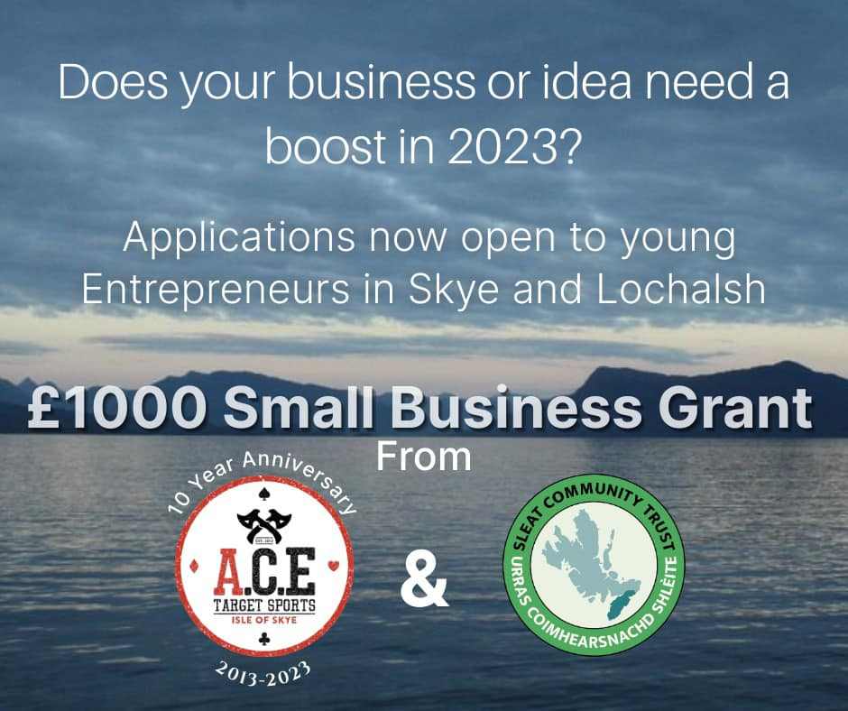
A.C.E./SCT Business Enterprise Competition 2023
open to young entrepreneurs aged 18 - 30.

APPLICATION FORM

Fill in the form below and return it before the end of September with any supporting information e.g. a short Powerpoint file.

Applications can be dropped into the Trust offices in Armadale, or e-mailed to chair@sleat.org.uk. Please copy in matt@ace-skye.com

1. Full name of applicant:

2. Address:

3. Contact details: e-mail: phone:

4. Name of Business (if applicable) :

5. In 150 words or fewer, please tell us what your business idea is and what impact the grant might have. This can be an existing business with a new idea, or an idea for a new business venture:

6. For an existing small business please detail any web or social media links:

For a new business please tell us how you will be looking to build up a following for your business idea:

Signature:

Date:

